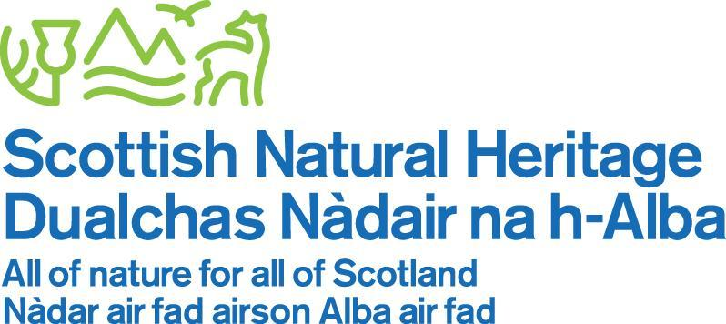

www.nnr-scotland.org.uk www.nature.scot

TENTSMUIR NATIONAL NATURE RESERVE

NEWSLETTER No. 38

June 2018

Welcome to the 38th Newsletter, now in its 19th year. I found it really difficult to get started on this newsletter … should I start with “I have Good news and bad news”, nah…however, after weeks of turning this over in my mind, here goes.

I have a lot of good news and one bit of bad news for you.

First the bad news - The Education Pavilion: this project failed to secure sufficient funding so has been put on hold. It was very disappointing!

Now the good news: all our management tasks were completed on time and we have had some wonderful wildlife monitoring with new species observed on the Reserve which our fantastic band of volunteers and experts have all contributed to, some great work by contractors and our own Reserve Staff.

Spring was late and summer has mostly arrived and the Reserve sites are slowly greening up and the wildlife is buzzing at last

Our summer events are changing a bit this year; with reduced budgets we are planning different style of events & activities. The planning and preparation work for the annual Family Day event are all going on apace.
Read on inside.

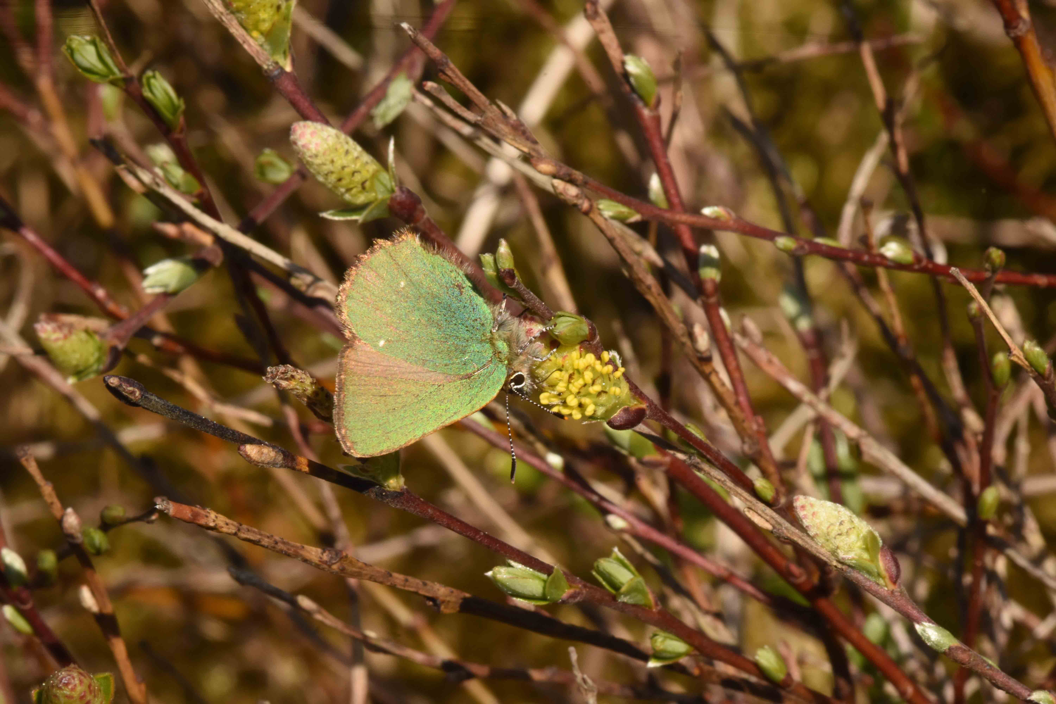

Green Hairstreak butterfly on Creeping Willow – Image by kind permission from Steve Buckland

Tom Cunningham
Reserve Manager
TENTSMUIR NATIONAL NATURE RESERVE

TENTSMUIR POINT

THE DYNAMIC COASTLINE

This year’s dynamic coastline changes have been astonishing especially at the north point and the dune edge erosion around the north eastern section has changed and the foreshore has built up.

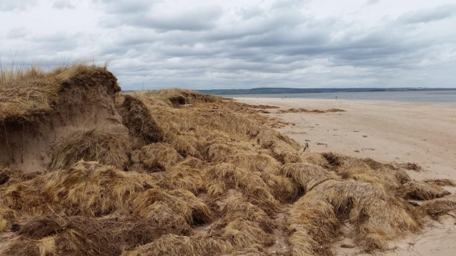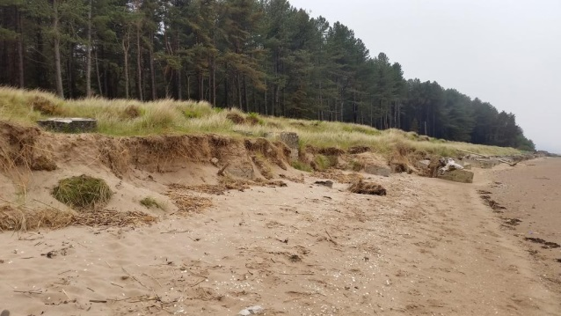

Images of the erosion: Image on the left is in the northeast area and the image on the right is at the north end by the sea fence.

MANAGEMENT

The Limousine cattle have returned to graze for the summer months and our thanks go to farmer Robert Lamont for providing the cattle and looking after them daily as well as carrying out some maintenance work on the Reserve. This includes repairing the recent vandalism on the cut wires on the north sea fence!

The annual sea fence repairs were carried out by Bob Ritchie and Mikey Smith; the south sea fence especially had taken quite a battering due to the unusually long period of storms, high tides and the occasional floating tree trunk requiring some extensive rebuilding.

Dave Mackie and his team will shortly start the targeted herbicide treatment of our invasive flora species on our three sites.

EDUCATIONAL ON THE RESERVE

THE EDUCATION and VISITOR PAVILION

Now the bad news. We worked tirelessly on the education shelter project to help take it from our architect plans, through planning, the building warrant and site clearance in 9 months - it was a remarkable achievement. We could not have worked with more commitment on this project especially towards the last month securing all manner of written support to accompany the funding application. We were left devastated as our funding bid failed. I am hoping that this is a temporary setback and the vision we have for the reserve will be realised. We hope you agree that this important facility will be a wonderful asset to Tentsmuir NNR.

However we have had another very busy year with 30 (27 last year) school visits during 2017/18 (this does not include the local weekly Forest School visits to the Reserve): Nurseries 5 (1), Primary Schools 6 (0), High Schools 13 (19), and Colleges 3 (3) & Universities 3 (7) and one Home education group visit. In addition we have carried out 6 joint visits with the RSPB bringing schools to Tentsmuir Point from areas in Dundee. In total well over 600 students attending.

Since 1998 we have had over 461 education visits to Tentsmuir Point & Morton Lochs which I estimate is well over 8000 students visiting. This Outdoor Classroom style is an important part of the education curriculum for pupils and students of all ages.

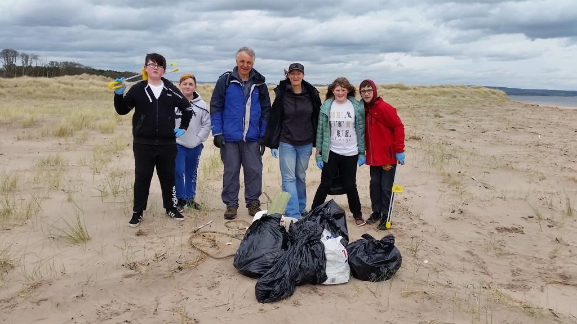

Auchmuty High School group carrying out a beach clean. A big thanks to the working party.

WILDLIFE UPDATE

BIRDS

The sea eagles successful raised one chick last year. However, it went missing on land further north a few months ago which is very disappointing. This year only the female has been seen around the area.

The skies above Tentsmuir Point and throughout the wooded areas and in the forest are alive with bird song - especially the skylarks, terns, the gull colony, crossbills, green and great spotted woodpeckers. We are a bit disappointed that we didn’t hear a cuckoo this Spring – has anyone heard one?

BUTTERFLIES AND MOTHS

I am delighted to announce that in June this year SNH will publish long-term volunteer Gillian Fyfe’s research report “A Report on Butterfly Abundance and Flight Periods at Tentsmuir National Nature Reserve, Fife from 1978 to 2015”.
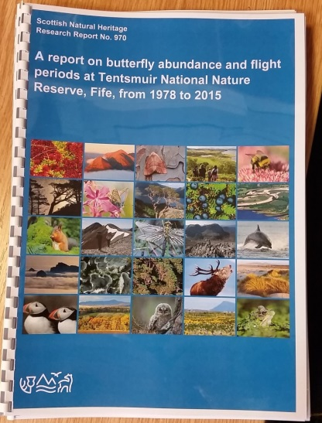 The front cover of Gillian’s research report
We will celebrate this wonderful achievement on Tentsmuir Point with a host of volunteers and experts and our new Chief Executive, Francesca Osowska when she comes to visit Tentsmuir later this month. My colleague Elspeth Christie put in a lot of work in taking the report through the process of quality assurance to getting the report finalised.

The butterflies seem to have had a better start this year with monitoring figures up on previous years. Daphne MacFarlane Smith, Elspeth Christie as well as Steve Buckland (see report below) were all thrilled to see the Green Hairstreak. Orange tip butterflies have had a very good start to the year especially at Morton Lochs

Hoverflies at Tentsmuir by Steve Buckland

Given its northerly location, there is a surprisingly wide variety of hoverfly species at Tentsmuir. The species are not at all evenly distributed. Hotspots for hoverflies include where the trees meet the dunes at Kinshaldy, the dunes near the ice house at Tentsmuir Point NNR, the track that runs from Leuchars to the beach along the edge of the army base, and in particular, Morton Lochs. At Morton Lochs, the most productive place to look for hoverflies is the railway path, which runs north and south from the car park. The stretch of path south of the car park from the bridge to the southern end is always worth checking on sunny days from April to September. The track into Morton Lochs where it passes between the two main lochs also attracts many species.

There are a few small patches of creeping willow amongst the dunes near the ice house. When it has catkins (mostly in May this year, perhaps due to the late spring), it can attract an impressive array of rare and scarce species, as well as several common ones. In just two visits in mid-May this year, I photographed the following species on the catkins: Cheilosia albipila, Cheilosia chrysocoma, Cheilosia fraterna, Chrysotoxum arcuatum, Dasysyrphus tricinctus, Dasysyrphus venustus, Helophilus hybridus, Leucozona lucorum, Melangyna lasiophthalma, Melanostoma scalare, Parasyrphus malinellus, Parasyrphus punctulatus, Parasyrphus vittiger, Platycheirus albimanus and Syrphus ribesii. There were also several Cheilosia bergenstammi on nearby dandelions, and the catkins also attract green hairstreak butterflies.

Along the paths at Morton Lochs, I have photographed 64 species since 2016, including Anasimyia lineata, Dasysyrphus pinastri, Didea fasciata, Eriozona erratica, Eriozona syrphoides, Leucozona laternaria, Melangyna umbellatarum, Parhelophilus versicolor/frutetorum, Scaeva selenitica and Tropidia scita.

Recording hoverflies has become much easier and more interesting with the rise of digital cameras. It used to be that specimens had to be taken to identify most species. While some remain impossible to identify without a specimen and a microscope, given good photos, most can now be identified at least to a species group. Photos can be submitted to the UK hoverflies Facebook page, where experts will help with identifying species. The activity makes for an interesting focus as well as a challenge if you are walking in and around Tentsmuir!

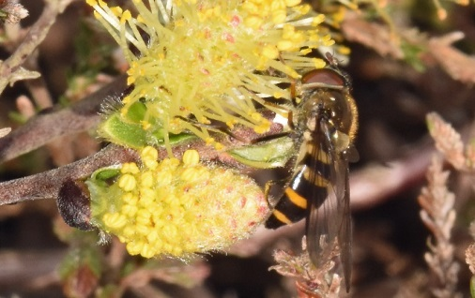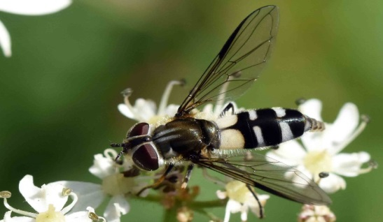
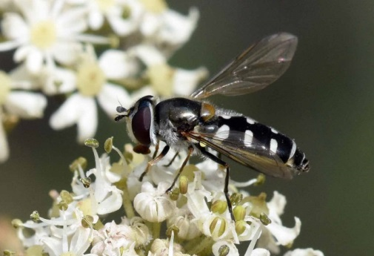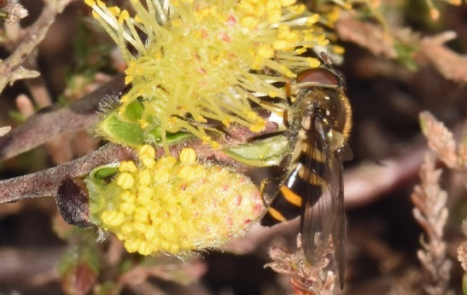

The images show: top left, Cheilosia chrysocoma, an impressive but elusive species with a patchy UK distribution; top right, Leucozona laternaria, an attractive species that is much less common than its better-known cousin, Leucozona lucorum; bottom left, Melangyna umbellatarum, another uncommon but nicely-marked species; and bottom right, Parasyrphus malinellus, a rarely-recorded species.

Thanks to Steve for this very interesting report and his continued invertebrate monitoring on the Reserve and Forest.

Professor Robert M M Crawford: Tentsmuir a Dynamic Landscape in a Changing Environment.

After 5 years of researching and writing, Bob’s book about Tentsmuir NNR and the Tentsmuir area is nearing completion. His work covers well over 10,000 years ago; tells the history of the people who once inhabited Tentsmuir and brings the reader up to date with current management of the Reserve. I am sure Bob will not mind me saying that he recently celebrated his 84th birthday. Bob began researching and teaching students in 1962/3 on Tentsmuir Point and his passion has continued abated! We are hoping that Bob’s brilliant work will get published at some point in the near future.

RESEARCH

By an amazing coincidence, Ciara Sugrue from the University of Loughborough is carrying out research on Tentsmuir Point; “Investigating the sensitivity of dune slacks to climate change and eutrophication”. Ciara will analyse all the monthly hydrological data we send her over the next two years, which is collected from four pipes that have been installed along a transect from an area near the dune edge through the slacks towards the forest boundary. The coincidence is, Bob Crawford started similar work and three of his original cast iron pipes laid down in 1963 are in the same area; Ciara has now installed her pipes alongside Bob’s. It will be amazing to compare the hydrology of the site today with the hydrology of over 55 years ago.

Fourteen research projects took place during 2017 and eleven are so far in place this year.

MORTON LOCHS

MANAGEMENT

The following management works were carried out over the last year:
- Improvements at the land bridge alongside the reed beds in the North Loch inflow. The flow into the North loch was hindered with only one narrow pipe, so a second pipe was installed and the gabion baskets reinforced.
- A spillway was installed at the same time by Scott Dalgleish of Arbuckle’s at the start of the west loch. This will enhance our capability of managing the flow through the north loch to help reduce nutrient build up and the the dense spread of aquatic flora.
- Dr Sascha Hooker & the student team from the University of St Andrews are continuing the water quality testing of the Lead Burn catchment area and through the Morton Lochs systems. This is continuing from last year and at no cost to SNH.
- Jim & Valerie Downie collected the hydrological data from the Morton Lochs Hydrological Network comprising the piezometers and data loggers every month. This will be the last year that Jim & Valerie Downie will carry out this task and I thank them both very much for their brilliant work. Stephanie will take up this work this year.
- The mink and grey squirrel control contract was carried out successfully at Morton Lochs and throughout the Reserve sites and further afield.

The reeds planted in the reed bed system created last year have grown and spread a little. We hope the plants will play an very important part in reducing the nutrients reaching the north loch.

WILDLIFE UPDATE

VIEW FROM THE SQUIRREL HIDE

This hide continues to be very popular and every day visitors can be seen watching the red squirrels on the feeders and trees. You can see some fancy cameras with huge lenses poking out of the hide viewing windows, hoping to catch them in action! In addition to the squirrels, you can observe woodpeckers, coal tits, blue tits, long-tailed tits, wrens, chaffinches, sparrowhawk, buzzard and, if you are really lucky, spot badgers snuffling around at the base of the trees picking at the dropped nuts.

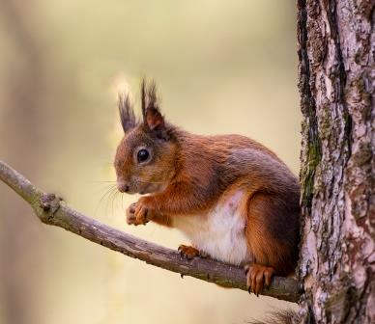

Image of a red squirrel on a tree opposite the Squirrel hide

DRAGONFLIES AND DAMSELFLIES

During the sunny May days there have been damselflies observed especially around the ponds and on the footpaths. Damselfly species observed so far include the Large Red, Blue tailed and Common Blue damselflies.

BIRDS AND OTHER WILDLIFE

The hides have been very busy with visitors and photographers hoping to see the kingfishers and while the kingfishers haven’t nested on the site they are still feeding on the lochs. New volunteer Ralph with Alex have been putting more perch sticks on the banks overhanging the water.
However, some visitors have been so eager to capture that special shot and have been walking in front of the hide and disturbing them. Please be aware the Kingfishers are a protected Schedule 1 bird, and as a gentle reminder, we have put up signs reminding visitors that it is an offence to intentionally or recklessly disturb at, on or near an active nest.

The squirrel feeders have been very busy, and it is wonderful to watch their antics and see the smaller birds, swifts, swallows, house martins, great spotted woodpeckers, long-tailed tits, blue tits, coal tits, great tits, wrens, chaffinches, jays, robins diving in and around getting a free feed.

On the lochs there are other notable sightings including otters, occasionally sea eagles, mute swans, gadwall, water rail, water voles, grey wagtails, little grebe, etc.

WHAT’S ON

FAMILY DAY OUT - Thursday, 5th July 2018 - “Tentsmuir’s, Time & Tide”. Starts at 1pm.

The nineteenth FREE annual NNR event will be held on Thursday, 5th July and it should be another fantastic, exciting day out and will tie in with the Year of Young People, and will be dedicated to the rich history and the flora and fauna on the Reserve and having plenty of fun.

As in most organisations our events budget has been reduced, but we will endeavour to give you another successful, fun and learning day out. The new-style shorter activity sessions will continue, so please squeeze in as many of the activities as you like, learn all about the Reserve’s plants and animals and be creative – you never know you may find your hidden artistic talents?

You may have a moment or two to wait after one activity ends and the next one begins, but come and enjoy, trying several different ones. Each activity will last 20 to 30 minutes. Activity leaders, colleagues and the volunteers will help you all the way.

The activities will be announced on the day as my colleagues are keeping me guessing.
(Including a wildlife art one)

The telescopes and binoculars will be on the foreshore ready for you to spy some of the wonderful bird life and seals.

Book early to avoid disappointment. With the exception of the £2 charge for the car park, it’s all free! (It’s now £2 at the barrier - please have change ready.) Please be at the car park for 12:30 ready to board the coaches which will bring you onto the Reserve.

There are normally 120 places available and the event books up fairly quickly. I also keep a reserve list, as there is usually a visitor or two who may have to cancel suddenly. If you are unable to attend after booking, please contact me as soon as possible to let me know, so I can call and let someone else take up your place. Please don’t let me or other visitors down. Remember a responsible adult must accompany all children. To book, please phone my office telephone 01382 553704 and if I am not in, please leave a short message on the answering machine with your name and telephone number and I will contact you to confirm the booking. If I do NOT contact you, you are not on my list!

You can always make your own way up to the reserve by foot or cycle just come and join us!

Morton Bioblitz For all - Thursday, 26 July 2018
No booking required for this new event and please note it will take place at Morton Lochs starting at 12 noon and we will let it run till around 3pm. Please park your cars sensibly in the car park as spaces will be limited. Learn all about identifying all the species, looking for birds, butterflies, dragonflies & damselflies, trees & flowers as well. We will have experts helping us and everyone can record all the species we find and contribute to our data base.

Tentsmuir Butterflies - Saturday, 4th August 2018

Led by Butterfly Conservation’s Duncan Davidson and Colin Edwards, this event will take place from the Kinshaldy car park walking up a route through the forest and dunes up through Tentsmuir Point. Due to its popularity, places are limited so please can contact Colin to book your place.

Colin Edwards
Butterfly Conservation: Scotland
Events coordinator Fife and Clackmannanshire
scotspinenut@hotmail.com

Summer Events with SNH and Forestry Commission Scotland
As in previous years we will also be holding two joint events with FCS staff events during the school summer holidays and they will take place in the picnic area at Kinshaldy car park.

THEY ARE FREE!! No booking is required, just turn up and join in the fun. 12:30pm to 3:30pm.

Thursday, 2 August 2018.

Thursday, 9th August 2018.

Activities for both events are still all in our heads but all will be revealed on the day. Both events will include the very popular Lisa’s Crafty Corner and RSPB staff will also have an information and activity.

STUDENT PLACEMENT – STEPHANIE HAWORTH

This year we have thoroughly enjoyed having Steph working alongside us; she is hard working and enthusiastic, a very fast learner and an all-round brilliant colleague. Steph has particularly enjoyed topping up the squirrel feeders every day, collecting the hydrological data, monitoring the butterflies and birds as well as carrying out all the daily management tasks. Steph has now finished her placement with us but we are delighted she will be continuing to help us on the Reserve as a volunteer.

VOLUNTEERS

Our wonderful group of volunteers continue to carry out the diverse amazing work on the NNR – without them we couldn’t possibly be as successful as we are. I will have an article or two about our loyal volunteers in the next Newsletter. It’s a huge thank you to all of our volunteers past and present who help to keep our fantastic Reserve in great condition.
Useful websites: for information on the Reserve and surrounding area, as well as our work in SNH. www.nature.scot

To keep up to date on our Facebook page “Scotland’s National Nature Reserves”, all you need to do is “Like” the page to follow us.

Tom Cunningham
Reserve Manager
Fetterdale Office
Tentsmuir Forest
by Tayport.
DD6 9PF
Telephone/Answering machine. 01382 553704. Email: tom.cunningham@snh.gov.uk

PS I think I have finally recovered from the dreadful season the once mighty Raith Rovers have endured. Following relegation two seasons ago we failed miserably to gain promotion, it was awful. But hey ho; onwards and upwards; the season ticket is purchased for next season (I will never learn) so, ‘Mon the Rovers!’

AND FINALLY
Hopefully good news for everyone, I had said I would retire once the Education Pavilion was completed – thinking this would be in 2017 or early 2018. I still hope this special project funding will come through. So I decided I will not retire at the moment. I thoroughly enjoy my work (except for ….. and … oh aye and ……) Now in my 20th year working on “Paradise NNR”, I still enjoy every minute of it. Another couple of years beckon.

