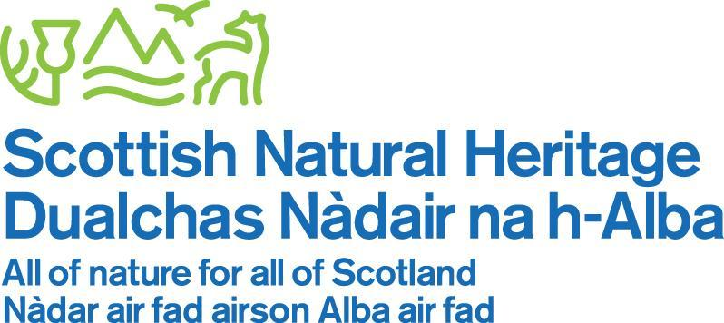

www.nnr-scotland.org.uk

TENTSMUIR NATIONAL NATURE RESERVE

NEWSLETTER No. 37

JUNE 2017

Welcome to the 37th Newsletter, now in its 18th year. It is hard to believe we have produced so many since July 1999 and … this edition will be my last second last one.

In this Newsletter, you will see the amazing management work we have been doing since the turn of the year. We have never stopped and it’s down to the hard work of the many dedicated volunteers, great work by contractors and our own Reserve Staff.

Weather wise, this year has seen some long dry and sunny weeks and then endured an awful lot of rain! The benefits of the rain, heat and sunshine throughout the Reserve sites and countryside is evident when you see the landscape greening up spectacularly.

As yet, the kingfishers haven’t been as showy when compared to last season’s amazing sightings. However, we have enjoyed several sightings of the sea eagles; as recently as last week, Alex & Ruari were lucky enough to have a good view of one around Morton Lochs – but neither had a camera or mobile phone handy!

2017 is going to be an especially busy year for Tentsmuir NNR and for me, the realisation of a dream project for Tentsmuir Point. (A Clue below)

The planning and preparation work for the annual Family Day event are all going on apace. Read on inside.

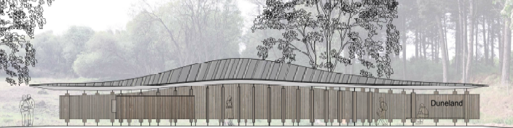

The North View of the Education Pavilion, architectural drawing by Kirsty Macguire.

Tom Cunningham
Reserve Manager
TENTSMUIR NATIONAL NATURE RESERVE

2017 Year of History, Heritage and Archaeology by Kirsty Fisher

The Scottish Government & VisitScotland have announced that 2017 has been designated the Year of History, Heritage and Archaeology, and will be the theme for this year’s Family Day Event. Kirsty Fisher has written the following article which I hope you enjoy reading

‘Tentsmuir National Nature Reserve (NNR) is undeniably a fantastic place for natural heritage, encompassing wetland, woodland and coastal habitats, which support a diverse range of plants and animals. Yet did you know just how significant this place has been for the history of people in Scotland?

My first experience of Tentsmuir NNR involved Morton Lochs, waders and a large pile of reeds which we were going to plant, but on this occasion, I was back on dry land to learn about the rich history of this diverse NNR.

Tentsmuir’s human history dates back to around 10,000 years ago with the arrival of Mesolithic man, who inhabited an island which is now part of fields at Morton Farm, just under 4km inland from the present-day shoreline. It is here that many archaeological artefacts have been found, including flints, grinding stones and cutting tools.

Throughout the years since then, Tentsmuir has played an important role in the lives of many people. Dr John Berry, an eminent Scottish naturalist and former director of the Nature Conservancy Council in Scotland, labelled Tentsmuir ‘Paradise’ for the special range of plants and animals found here, and it’s astounding natural beauty.

Tentsmuir’s name is thought to have been derived from ‘Tents on the moor,’ though a number of arguments about its origin have been put forth, ranging from ‘Tents lived in by early shepherds,’ to the Scottish name, ‘Densman’, in reference to Danes thought to have been shipwrecked off the coast. Either way, the idea of 'Tents on the moor' became ever-more pertinent when World War 2 came knocking at Scotland’s door.

Hidden among the trees at the Forestry Commission-managed Tentsmuir Forest are the remains of WW2 buildings set among the quiet rustle of trees and the loud calling of birds. Yet during the war, these areas would have contained a bustling army camp.
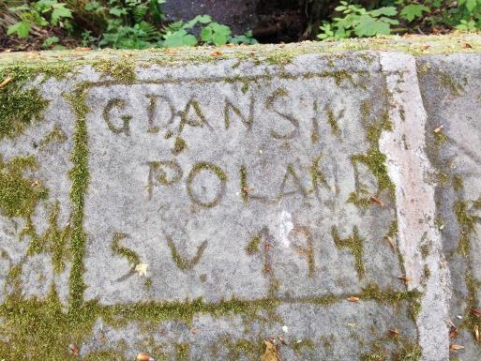
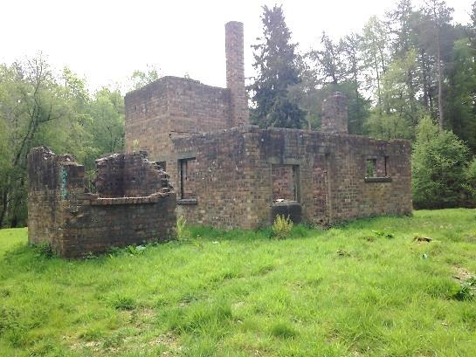

Left to right: Army camp buildings in Polish Camp Road in the forest. Polish Eagle emblem on the well & Graffiti on a trackside bridge

Coastal defences were vital in deterring invasion of Tentsmuir’s open, sandy shores and as such, many Polish soldiers were based here, making Tentsmuir home from around 1940 until the war was over. In as much as Tentsmuir left a mark on them, with many staying in the Fife area after the war was over, the Polish army also left visible reminders of their contribution here. This can be seen in the moss-covered graffiti on a bridge within the forest, dated ‘1941’, as well as the Polish Eagle coat of arms carved on a well which would have served the building at ‘Polish Camp Road’.

Nearer the coast, the tank traps stand proud along the dunes. These concrete blocks’ primary use as deterrent and defence played a crucial role in preventing enemy attack on the Scottish Coastline during World War II. When German planes flew over from occupied Norway, their reports stated that Scotland’s coastlines were very well defended, which ultimately discouraged them attacking and shaped the history of the war.

Marking the high tide mark of when they were first instated in 1941, they are now slightly covered by the sand which has claimed many more of the relics left over from the war, including a railway cart, discovered by Tom in 2010, which was used for bringing in supplies and latterly, as a moving target used by the Royal Air Force.

Nowadays, the shoreline stands more than 350 metres away at some points, showing just how dynamic the coastline of Tentsmuir is. In addition, while I marvelled at just how much difference over 70 years can make, Tom explained that Abertay Sands, the thin strip of sand banks just off Tentsmuir point, can visibly change on a daily basis. It’s no wonder, then, that so many schools use Tentsmuir as an excellent example of coastal processes.

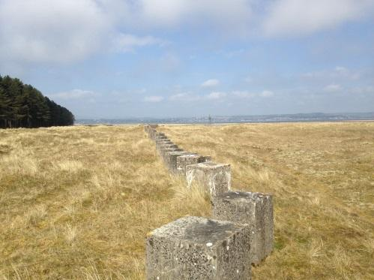
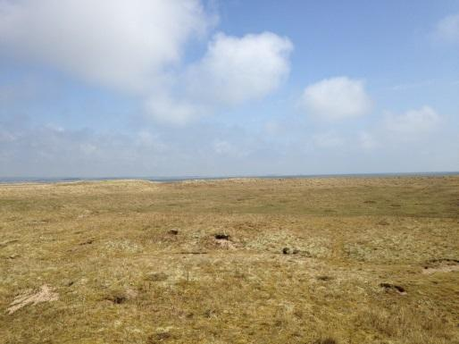
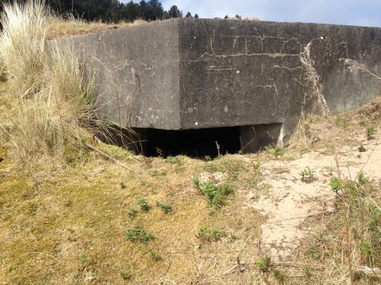

Left to Right: Tank traps down at the coast; a gun emplacement among the concrete blocks; the distance from the defences to the coast today (the sea can just be seen above the land in the image).

While there are many more interesting historical artefacts to be seen at the NNR, such as the March Stone delineating the fishing rights in 1794 and the Ice House dating from 1888, once used to keep the fish fresh, I will leave some of these relics to be discovered on your next visit to Paradise NNR.

To end my day, much like Tentsmuir’s recurring ‘tents on the moor’ theme, I ended up back in waders at Morton Lochs helping with fencing to stop the grazing cattle from entering the loch. Along with all the fascinating stories I learned about Tentsmuir’s history, an important additional lesson from my trip to Tentsmuir NNR was never to assume, based on eyesight alone, that the water is not as deep as your waders…

Thank you very much to Tom and Ruari for all your help and wonderful stories about the fascinating history of Paradise NNR.

Keep an eye out for more posts, pictures and videos about the history, heritage and archaeology of SNH’s National Nature Reserves on the SNH and NNR Facebook pages (links below).

Scottish Natural Heritage: https://www.facebook.com/ScottishNaturalHeritage/

Scotland’s National Nature Reserves: https://www.facebook.com/ScotlandsNNRs/

TENTSMUIR POINT

THE DYNAMIC COASTLINE

This year’s dynamic coastline changes have not been as severe as in previous years and remains more or less in the same shape as last year.

THE EDUCATION and VISITOR PAVILION

As you can guess from the image on the first page we have at long last gained funding this year to build the important Education and Visitor Shelter. (Jumps up and shouts hooray!) Architect Kirsty Maguire had been commissioned to provide the drawings last year and we were suitably impressed. The next step is to apply for Planning Permission and a building warrant from Fife Council and put the work out to tender with a view to start building work in the autumn.

This is the one facility we lack on the Reserve especially on Tentsmuir Point despite having had had a highly successful Education Programme for over 17 years. Teachers were telling us we need a shelter when the weather changes and some-where to site. This new facility will provide the perfect place from which to start the school, college and university visits and also provide shelter and seating not only for the students but also for all our visitors.

The Education Shelter or the Pavilion as Kirsty describes the structure will be sited on a piece of land just inside the Icehouse entrance to Tentsmuir Point. It will sit within the birch alder woodland on land previously disturbed by the clearance of the boundary ditch. It will sit within the wooded landscape but provide open views out towards the duneland - a perfect entrance to the Reserve, at home in its environment.

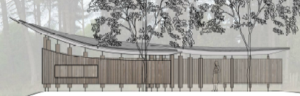

Education Pavilion the East Elevation. Drawing by Kirsty Macguire

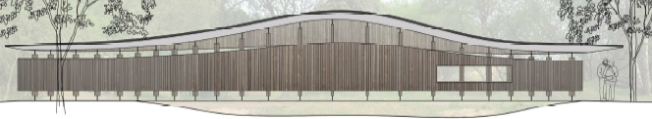

Education Pavilion the South Elevation. Drawing by Kirsty Macguire.
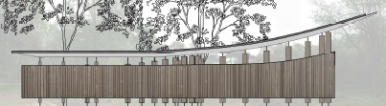

Education Pavilion the West Elevation. Drawing by Kirsty Macguire

We hope you agree that this important facility will be a wonderful asset to Tentsmuir NNR.

We are unsure what this Education Facility should be called; Pavilion and Shelter are a bit dry, and ask if you would suggest and alternative name for this brilliant new facility? No actual prize – just the kudos …

MANAGEMENT

The Limousin cattle will be returning to graze throughout the summer months and our thanks go to farmer Robert Lamont for providing the cattle.

McIntosh & Robertson, with digger driver Bill Martin, cleaned out the Cleek burn on the north part during the Spring months.

The sea fences were repaired by Bob Ritchie and Mikey Smith and the south sea fence especially had taken quite a battering and this was repaired during the annual service.

Dave Mackie and his team will shortly start the targeted herbicide treatment of our invasive flora species. We also hope to trial a special Soft Track machine that will cut the rosebay willow herb before it seeds. This will be year 1 in this new management of the plant which has spread thought the dune system and in places is dominant. We are hoping that cutting will weaken the plant and reduce is vigorous growth drastically.

EDUCATIONAL VISITS

Educational visits are slowly picking up this term with High School visit numbers on the up. Shonagh Barbour of Bell Baxter High School had 20 third year pupils on the Reserve for four days studying sand dune succession and carrying out the work towards their John Muir Award ‘Giving Something Back to the Environment.’

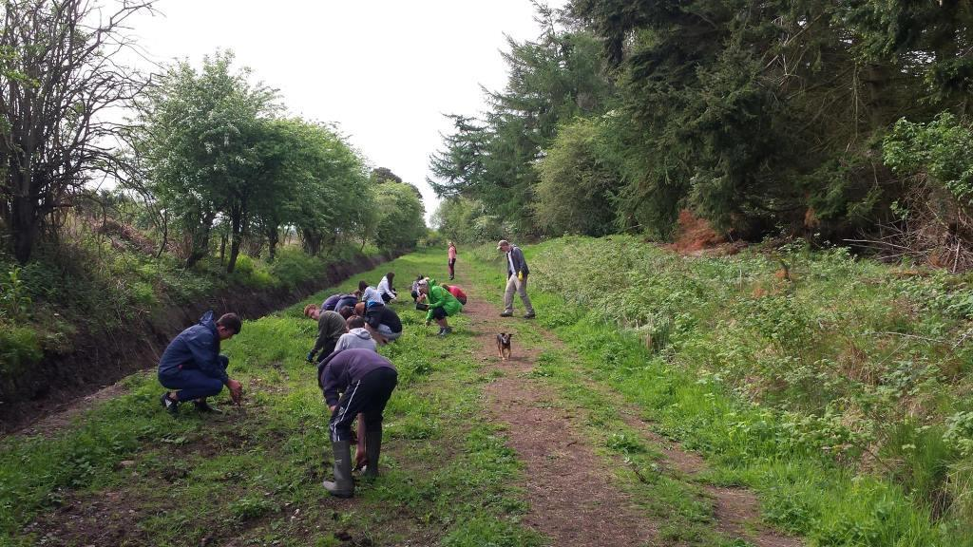

Bell Baxter High School pupils planting wildflowers along the south loch footpath

WILDLIFE UPDATE

SEA EAGLES

The sea eagles have been observed on occasions as they fly around Fife, and recently been seen around Morton Lochs. Keep your eye on the local newspapers for a press release from the RSPB.

BUTTERFLIES AND MOTHS

I am delighted to announce that SNH will publish long term volunteer Gillian Fyfe’s research report “A Report on Butterfly Abundance and Flight Periods at Tentsmuir National Nature Reserve, Fife from 1978 to 2015”. We are obtaining maps and images to complement this wonderful piece of work by Gillian.

The butterflies seem to have had a better start this year with monitoring figures up on previous years. Daphne MacFarlane Smith was thrilled to see the Green Hairstreak.

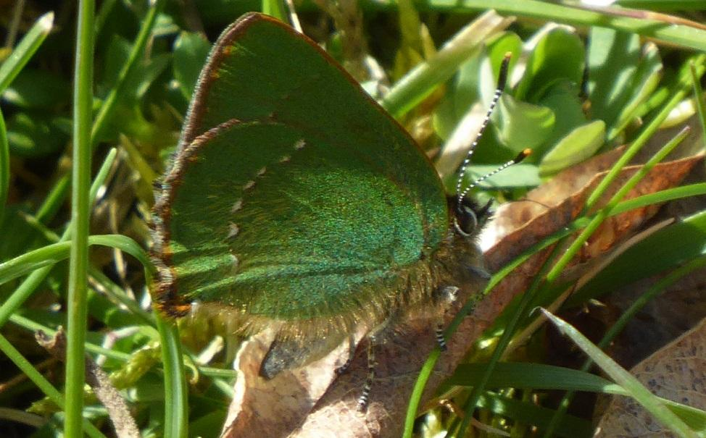

Green Hairstreak by Daphne MacFarlane Smith.

Student Placement Ruari Dunsmuir has started carrying out moth trapping and his ID skills are
improving with each survey. Ruari has kindly provided an article, which will include his mothing surveys.

MORTON LOCHS

MANAGEMENT

Large scale management projects continued at Morton Lochs with Bill Martin the digger driver for McIntosh & Robertson very skilfully creating two large areas within the Lead Burn inflow to the north loch to create a reedbed filtration system. Bill was able to excavate reeds from the north loch margins and transport them to the new reed beds for us. Bill also excavated the old railway line ditches along the south loch footpath. As you can see from the Bell Baxter High School images the areas was left in a bit of a mess although Bill levelled the ground as his tracked digger exited the work site.

We took advantage of the water levels which had been deliberately lowered to allow excavation work to go ahead, and a group of colleagues and volunteers helped us plant up reeds in the prepared beds.

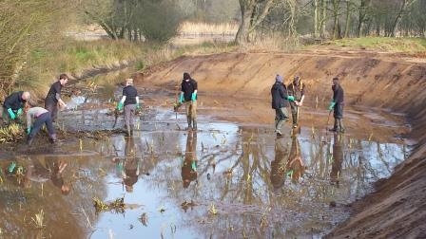

Volunteers & colleagues planting reeds

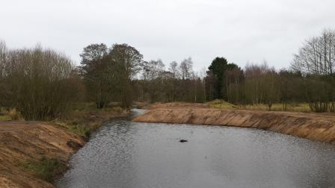

A day later with the water levels back to normal

DIFFUSE POLLUTION AT MORTON LOCHS

The reed bed system will be a very important part of reducing the nutrients reaching the north loch. Research by Dr Sascha Hooker and the student team from University of St. Andrews continues into the water quality of the Lead Burn and in the North Loch. We await the results at some point during the year.

WILDLIFE UPDATE

VIEW FROM THE SQUIRREL HIDE

This hide continues to be very popular and every day visitors can be seen watching the red squirrels on the feeders and trees. You can see some fancy cameras with huge lenses poking out of the hide viewing windows, hoping to catch them in action! In addition to the squirrels, you can observe woodpeckers, coal tits, blue tits, long-tailed tits, wrens, chaffinches and, if you are really lucky, spot badgers snuffling around at the base of the trees picking at the dropped nuts.

DRAGONFLIES AND DAMSELFLIES

Already during the sunny May days there have been damselflies observed especially around the ponds and on the footpaths. Damselfly species observed so far include the Large Red, Blue tailed and Common Blue damselflies.

BIRDS AND OTHER WILDLIFE

The hides have been very busy with visitors and photographers hoping to see the kingfishers and have flocked to see them, which is wonderful. Some visitors have been so eager to capture that special shot and have been walking in front of the hide and disturbing them.

Please be aware the Kingfishers are a protected Schedule 1 bird, and as a gentle reminder, we have put up signs reminding visitors that it is an offence to intentionally or recklessly disturb at, on or near an active nest.

The squirrel feeders have been very busy, and it is wonderful to watch their antics and see the smaller birds, swifts, swallows, house martins, great spotted woodpeckers, long-tailed tits, blue tits, coal tits, great tits, wrens, chaffinches, jays, robins diving in and around getting a free feed.

On the lochs there are other notable sightings including otters, occasionally sea eagles, mute swans, gadwall, water rail, water voles, grey wagtails, little grebe, etc.

WHAT’S ON

FAMILY DAY OUT - Thursday, 6th July 2017 - “Tentsmuir’s, TimeLine Treasures”. Starts at 1pm.

The eighteenth FREE annual NNR event will be held on Thursday, 6th July and it should be another fantastic, exciting day out and will tie in with the Year of History, Heritage & Archaeology, and will be dedicated to the rich history and the flora and fauna on the Reserve and having plenty of fun.

The new-style shorter activity sessions will continue, so please squeeze in as many of the activities as you like, and learn all about the Reserve’s plants and animals and be creative AND see if you find the buried treasure? This new activity is linked with the history of the Reserve, where a Polish Army Officer invented the mine detector, which is effectively a metal detector.

You may have a moment or two to wait after one activity ends and the next one begins, but come and enjoy, learn and try several different ones. Each activity will last 20 to 30 minutes. Activity leaders, colleagues and the volunteers will help you all the way.

After last year’s hugely successful and fun time main attraction with Cat Frankitti I asked if she would like to come back this year. Cat was so enthusiastic and you will all have so much fun and learn so much, I cannot wait!! The attraction is called “Pirates of Paradise” Cat, her husband John and assistant Pete will provide food tasting, hunter-gathering and lot of pirate shenanigans – you’d better find out for yourselves on the day!

There will be small prizes for the best Pirate costume for a young visitor and parent! Ship Ahoy!! Oooo Aaaaarrrrrr Me Hearties!

The telescopes and binoculars will be on the foreshore and there are 8 activities. We have two which my colleagues are keeping me guessing, but so far we have:-

- Folding Craft birds & animals - with David Mitchell, Caroline & Myra
- Food with Fire – with Cat, Pete & Johns
- Tentsmuir’s Top Ten Bug Hunt – with Gillian & Ailsa
- Picture It – with Kathryn Green & Allison
- Buried Treasure – Alex & Ruari and Kirsty
- Sea Eagles Scavenger Hunt – with the RSPB Lauren Shannon & Richard
- Telescopes on the Foreshore – with Hannah & Andy
- And more activities when the thinking caps are back on my colleagues heads :)

Book early to avoid disappointment. With the exception of the £2 charge for the car park, it’s all free! (It’s now £2 at the barrier - please have change ready.) Please be at the car park for 12:30 ready to board the coaches which will bring you onto the Reserve.

There are normally 120 places available and the event books up fairly quickly. I also keep a reserve list, as there is usually a visitor or two who may have to cancel suddenly. If you are unable to attend after booking, please contact me as soon as possible to let me know, so I can call and let someone else take up your place. Please don’t let me or other visitors down. Remember a responsible adult must accompany all children.

To book, please phone my office telephone and if I am not in, please leave a short message on the answering machine with your name and telephone number and I will contact you to confirm the booking. If I do NOT contact you, you are not on my list!

Summer Events with SNH and Forestry Commission Scotland

Alex and I, supported by some of our wonderful volunteers and student placement, will also be holding three events during the school summer holidays and will take place in the picnic area at Kinshaldy car park.

THEY ARE FREE!! No booking is required, just turn up and join in the fun. Starts 1pm and finishes 3:30pm.

We will be running events in and around the car park and picnic area between 12.30 pm and 3 pm on the following days:

27 July 2017

Ruari’s Butterfly Bonanza:
- Build a butterfly ID wheel
- Make butterfly feeders
- Learn how to make your garden butterfly friendly
- Lisa’s Crafty Corner
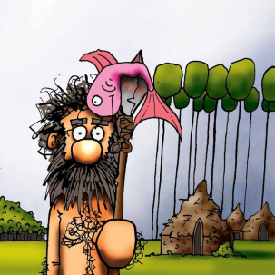
3 August 2017

Tentsmuir’s Timeline Treasure’s

Search for Tentsmuir’s hidden treasures
- Scavenger hunt
- Crafty Corner with Lisa
- Conquer the quiz trail

10 August 2017
Now You See Me – Now You Don’t!
- How do animals camouflage themselves?
- A Corner Craft workshop with Lisa
- Play the Camouflage Game

STUDENT PLACEMENT - RUARI DUNSMUIR

This year we have thoroughly enjoyed having Ruari work alongside us; he is hard working and enthusiastic; a fast learner and an all-round brilliant colleague. Ruari wrote the following article about some of the management tasks & activities and projects in which he is involved.

‘Tentsmuir NNR consists of three sites; Tentsmuir Point, Tayport Heath and Morton Lochs. This diverse set of habitats and associated species make it a wonderfully varied and interesting Reserve. My time is spent performing a number of management tasks to improve the quality of the Reserve for both wildlife and people. Core tasks consist of practical conservation management, leading volunteer groups, visitor management, and species monitoring, and assisting with educational events. Being involved in such activities is highly rewarding, engaging, and for me highlights the complexity of the work and the number of tasks required to manage and maintain the Reserve.

As the year moves forward and the weather improves, the Reserve feels like it is wakening up after a long winter and with it come more opportunities to get out and do different types of species monitoring. This can include dragonflies, damselflies, squirrels, butterflies, moths, birds, and plants.
Surveying and monitoring wildlife at Tentsmuir is important to help us manage the Reserve in the best possible way for conservation. This will safeguard species and their habitats for future generations. Therefore, we need to have up-to-date information on the condition of the habitats, the species present on site, and population trends of important plants and animals.
Many people are intimidated by the challenge of counting wildlife or worried about incorrect identification. Personally, I love the challenge and the opportunity to see as much wildlife as possible. Currently my passion is moths.
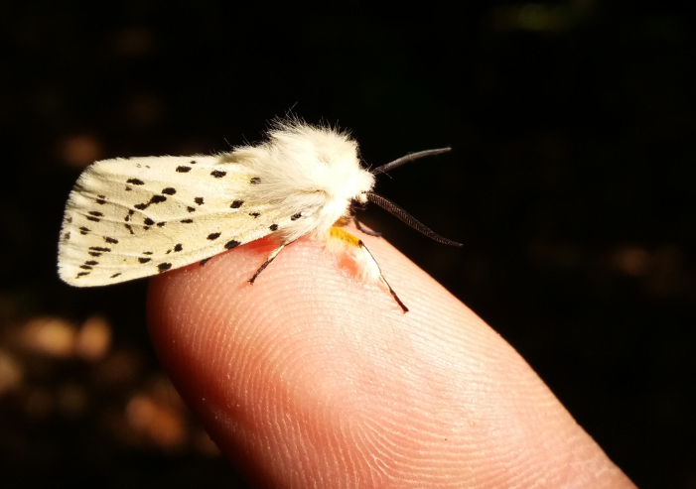

White Ermine [Spilosoma lubricipeda]
I find it really exciting walking up to the trap in the morning wondering what is going to be in it (if anything). I did not start moth recording until a few months into my placement at Tentsmuir so at the moment I am still finding species I have not seen before. Additionally, moths really make you work and test your identification skills. Yes, there are many species which are brightly coloured or have distinctive, clear, helpful markings. But then there are the ‘small brown jobbies,’ as my college lecturer used to say, about any small brown seemingly indistinct species. These can be particularly difficult to correctly identify and more often than not, require a photograph and a trawl through a book or the internet. And even then, just to make a bit more challenging, some species can look incredibly similar and wing patterns can fade over time. Correctly identifying these is extremely rewarding.

What got me into moths? I feel they are generally under recorded and overlooked by many people despite having a great aesthetic appeal. They are beautiful and have the enigmatic appeal of all nocturnal animals while also having some fantastic common names. Small Phoenix, True Lover’s Knot, Smoky Wainscot, and Chimney Sweep, to name but a few. Moths also play a vital role in telling us about the health of our environment. They are widespread and sensitive to changes making them particularly useful as indicator species. Monitoring their numbers and ranges can give us vital clues to changes in our own environment, such as the effects of new farming practices, pesticides, air pollution and climate change. In the end though, I just really enjoy seeing these wonderful animals and as my work progresses at Tentsmuir I want to continue to learn as much as possible and gain more experience of Reserve work, in an effort to make a positive contribution both for wildlife and people.
Useful websites: www.snh.gov.uk and www.nnr-scotland.org.uk for information on the Reserve and surrounding area, as well as our work in SNH.

To keep up to date on our Facebook page “Scotland’s National Nature Reserves”, all you need to do is “Like” the page to follow us.

Read about all of Scotland’s NNRs in our NNR Visitor Guide 2017

Tom Cunningham
Fetterdale Office
Tentsmuir Forest
by Tayport.
DD6 9PF
Telephone/Answering machine. 01382 553704. Email: tom.cunningham@snh.gov.uk

PS I think I have finally recovered from the dreadful season the once mighty Raith Rovers have endured. Relegation did eventually come; it was inevitable we were truly awful. But hey ho; onwards and upwards; the season ticket is purchased for next season (I will never learn) so, ‘Mon the Rovers!’

AND FINALLY (well, my second last Finally)

I will retire this year after 20 years working on “Paradise NNR”, and I have enjoyed every minute of it. I have so many people to thank for supporting me and working for us on the Reserve over the years. (I was not happy relying on my memory, so on investigating I found that I had started as the Assistant Reserve Manager in June 1997.)

From the fantastic teachers at the nurseries, primary and high schools who flocked along to the Reserve as we encouraged them to study in the Outdoor Classroom using the wonderful Tentsmuir NNR Education Pack: Life in the Sands. From Moscow and La Vallee de la Loire in France and all over the UK to the schools on our doorstep, the schools loved studying here. Thank you all

To the Colleges, especially Elmwood College and Stuart MacDonald in particular; to the great range of UK Universities, who used the Reserve to study, teach and carry out a massive amount of Research on this amazing National Nature Reserve. Thank you all.

Some very special thanks go to the following truly amazing people who supported me and the Reserve.

Professor Rob Duck. Professor Bob Crawford. Dr Jim Steward (Deceased and sorely missed) who set the bar at an incredible height, and was the first Poet in Residence in 2013. Derek Robertson - the first Artist in Residence during 2013. Bernie McConnell, Ailsa Hall, Professor Sir David Read, Stuart MacDonald, Jim Allan, Sheila Brinkley, Jean Stewart, Donald Stewart, Tam Ross, Andrew Ford, Pete Cunningham, Professor John Rowan, Keith Skene, and all the special people who work in the various Geosciences departments; Gerald Lincoln, David Bryant, Duncan Davidson, Pat Dugard, Marek Malecki. Thank you.

Other brilliant volunteers include: my first volunteer Maxine Reekie and her boyfriend Kevin Little. Then there is a whole host of Elmwood College Conservation Management students including the lovely Eve Schulte, Ian Jamieson, Alasdair McLeod, Craig Baxter, Mandy Dougal, Andy Smart, Robert Bell, Lee Robertson, Brice Coe, Lynda Oxley, Steve Fordsham, David Brattesani, Ali Campbell and Willie Doig. Thank you.

I also want to thank some more great volunteers including Elisa O’Hare, Karen Caddell Walker, Ana Viera, Julia Mifflin, Tom Stevenson, Anne Frost, Cath & Ron Warrender, Emma, Lesley, Jim McCann, Craig Ferries, Mary Bensted, Kirsten Campbell, Kirsten Brewster, Nicola Williamson, Corryn Christie and the late Jim Rougvie. There are a good many more volunteers and groups who came along for a day or two and supported us carrying out a massive amount of work. I Thank you.

Lastly, but by no means least; a group of fabulous people who have worked tirelessly (and a good number put up with me for many years) carrying out vital monitoring work - Daphne MacFarlane Smith, Gillian Fyfe, Ailsa Malcom, Anne-Marie Smout, Paul & Ruth Blackburn, David Mitchell, Gerry Callaghan, Bill Alexander, Tam Ross, Alan Foulds a massive thanks to you all.

Reserve Staff; I started as Assistant Reserve Manager to the great Dave Bonnet (RIP) and Gordon Wardrope, Alex Easson, Blair Johnston and Ruari Dunsmuir. Thank you.

Forestry Colleagues – Alex again (job share FCS & SNH), Graham, John, Robin and in the past Bid. Alex and I have worked together for over 16 years and we have achieved a whole host of successes on the Reserve, it has been great. Thank you.

A host of lovely people who send me wildlife data and images – Bob Willis, Steve Hubbard, Chris Reekie, John Cumming, Daniele Muir, Steve Buckland, John Nadin, Ian Ford, Jacqui Herrington and Andrew Hodgson. Thank you.

A whole host of fantastic and hardworking contractors who carried out some amazing work on the Reserve sites include Dave Mackie with Moray Stewart, Jim Allan, McIntosh & Robertson especially digger driver Bill Martin, Jim & Valerie Downie all have contributed hugely to the successful contracts.

The fantastic Cat & John Franchetti who have had many years of putting up marquees, flags, tables, etc, and then brought their magical activities and fun to the last three Family Day Events. Special people who also made the activities so much fun are Kathryn Green, Gillian Fyfe and Maggie Gay. Thank you

A very special mention to my darling wife Pete Cunningham who has had to put up with me, bringing work home; she is my editor, spellchecker and an extraordinaire wordsmith! Thank you.

Oh my goodness “The Big One” I have much to thank, – Caroline Gallacher, my boss for 20 years – what a team! Thank you very much.

Thank you also to my other fantastic Cupar Office colleagues. Rosemary, Allison. Myra, Dave, Gavin, Elspeth, Iain, Kath, Sarah, Keith and in the past Elena, Eleanor, Julie, Catherine, Isobel and a whole host of fantastic SNH colleagues throughout the organisation especially David Rodger, Heather Kinnin and Vicky Mowat who helped me throughout and put Tentsmuir NNR on the map and also the NNR team Susan, David & Stewart. Thank you

And to all the amazing talented group of fantastic NNR Reserve Managers & Reserve staff … what a team we are! SNH should be proud of us and our Special Places

Apologies if I missed anyone out, it was not deliberate, it’s just the grey cells aren’t as good as they were.

Way hey, I will miss you all.

