DRUMOIG WILDLIFE NEWSLETTER NUMBER 5 – NOVEMBER/DECEMBER 2021

November was unseasonably mild for the most part and there was lower rainfall than usual (22.3mm). However, November ended with a bang in the form of Storm Arwen with half the month’s rain falling in the last few days.
December saw 57mm of rain and the “D” of December could have been representative of numerous adjectives beginning with “d” – dark, damp, dreich, dull, dank, dreary and dismal!!

STORM ARWEN.
Storm Arwen had quite an impact on Drumoig with numerous trees toppling over. Fir trees were most affected as, of course, they have needles, which provide some resistance in high winds and they also have shallow roots. The downed trees were scattered all over Drumoig but the driving range car park was badly affected with several trees bringing down the fence and a lamp-post.
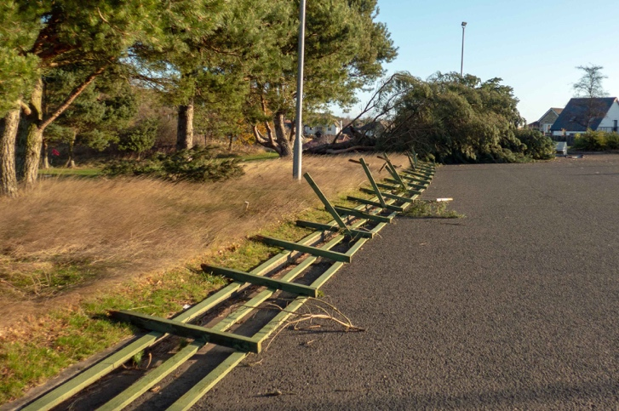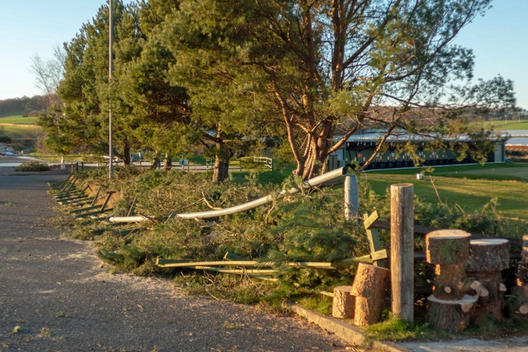
Driving range car park from the west. Driving range from the east after clearing

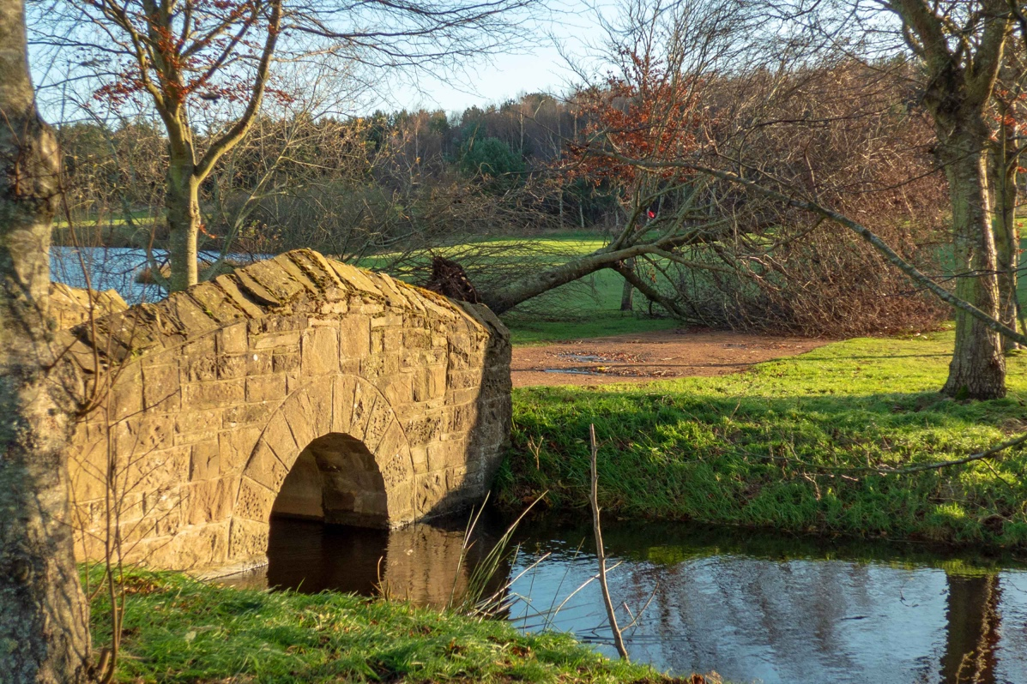
Tree down near the 11th green

I was miffed to hear that residents in Craigie escaped the power cut endured by those of us in Forgan and Comerton. It was an extended cut of 7 hours, which is long by recent standards, but fades into insignificance compared to more remote sections of the country who were without power for the best part of a week.
I also heard that Haddo House near Aberdeen lost 100,000 trees to Storm Arwen so, on that basis, we got away very lightly!

ANDREW SIMPSON, VICARSFORD FARM, TAYPORT.
A number of years ago I wrote a piece about the Vicarsford piggery for the DRA Newsletter, much of the content is still relevant although the actual running of the pig enterprise is now under the control of the major food production and processing group Kerro Foods, based in Yorkshire This in turn has only recently (Oct 21)been merged with the major Canadian food processing company Sofina Foods
In the past there were up to 700 sows producing piglets which were then fattened in the large sheds at Vicarsford before going for pork/bacon production. The sow numbers have increase to around 900 but the offspring (weaners) are only now held for a limited period of time, before being transported to farms, mainly in Yorkshire, for fattening, these are nearer to the final processing factories, saving haulage costs
Currently the breeding sows are held further up the hill behind the farm on land farmed by Kirkton Barns farm, where the piglets are farrowed in about 280 enclosures. They have a reciprocal deal where Kirkton Barns take the FYM in return for the land rental.
Some of the details in my previous piece are still relevant inasmuch as the gestation period for a sow is 3 months 3 weeks and 3 days, with an average litter now around 14.5 piglets per sow. Under normal conditions a sow will produce 2.4 litters per annum The sows are a mixture of Landrace and Duroc breeds
The remainder of the farm, still owned by Andrew Simpson, some 400 acres produces cereals, mainly wheat., potatoes and vegetables As previously mentioned the pig farm was formally known as Cowbakie which of course is the name of the 3rd hole at Drumoig golf course. The field adjacent to the golf course which produced potatoes last year and wheat this year will probably be down to carrots next season
Andrew Simpson farms at Parbroath farm near Cupar as well as Vicarsford and other land; he also owns a large number of holiday lets around Fife
Interestingly, and especially for those who follow Formula One (F1) Safina Foods own the Williams F1 team and the Canadian driver Nicholas Lafiti is the son of the CEO of Safina Foods!
Rob Pirie

THERE’S BEEN A MUURRRRDER
Rob Pirie recently e-mailed with the following poser – “I don’t know if you had noticed recently the huge numbers (100’s) of crows flying around in flocks or a “murder”? I wonder if anyone knows the reason for this behaviour?”
Searching the internet with the help of my friend, Mr. Google, I came across some interesting, if inconclusive, facts.
One theory is that, as temperatures get cooler, crows form large groups that number in the hundreds or even thousands. Not much has been studied as to why crows gather in such large numbers.
Other theories include “roosting provides safety in numbers”; “large numbers keep them warm”; “large numbers help to find sources of food using collective wisdom”, but none of these theories seems particularly convincing or scientific.
There is a myriad of terms for flocks of crows – a murder, a mob, a muster, a parcel, a hover, a horde and a roost. Crows are known to have a tight-knit family structure and are often associated with the macabre such as dead bodies (they are scavengers, of course), cemeteries and battlefields. Closer to home, we recently noticed a pair of crows on our neighbour’s roof, greedily demolishing the carcase of a baby rabbit. Whether they had committed the murder themselves or it had been perpetrated by another agency is apparently not known to the local constabulary.
So, the answer to Rob’s query is that nobody knows. If anyone has any additional information, please submit it on the back of a £5 note and it may be considered for publication.
Rob had the bright idea of videoing the flocks but as soon as he thought of it…..the flocks, musters, murders etc disappeared!! But Rob did contact me a few weeks later to say “I never did manage to catch on video the crows in flight but I did notice last week they were congregating in very large numbers on the field of straw covered carrots on the right-hand side of the road between Fordelhill and St Michael’s. Assume they’re rooting around in the straw for grain/seeds/ bugs or whatever!”

VULTURES OVER DRUMOIG
It may never happen but you never know with all this global warming stuff going on! Dave and Lil Smith sent this photo of Griffon vultures perching with intent near their home………….…in Cyprus!

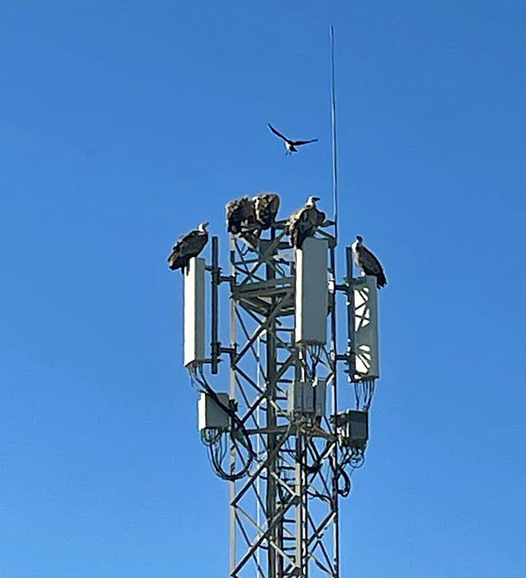

OUR LAWNS
I recently came across a series of articles on the RSPB website about lawns and thought I would share some of their ideas with you. As an aside, when we first arrived in Drumoig our small lawns were in a dreadful state and had a fungus growing that just about obliterated any feeble blades of grass. I thought we’d have to dig it up and start again but we consulted Lawnmaster, who identified the fungus as dog something-or-other and promised that they could get rid of it. Amazingly, after 6 weeks the fungus had all but disappeared and the grass was thriving. We have continued to use Lawnmaster and I have to say that anything they spread on the lawn is infinitely more effective than anything from B & Q! I also know that several lawns in Drumoig have “died” despite the best efforts of their owners. This may well be due to the underlying sand on which many of the plots are built with insufficient topsoil being provided.
As the RSPB point out, lawns are havens for wildlife as well as being social spaces to play or relax with family and friends. Certainly, whether seeding or laying turf, there needs to be adequate preparation in terms of breaking up and levelling the soil, which probably did not happen on some of the plots in Drumoig. An alternative to a well-trimmed lawn is a “flowering lawn” which contains a mixture of fine grasses and flowers, which can cope with regular mowing. If you take a hands-off approach to gardening a general-purpose meadow turf or seed mix will allow you to leave the grass uncut for a leisurely 8 -12 weeks in summer. I know of 2 friends who have taken this approach and have enjoyed the change of wildlife this has brought to their garden. Even with a well-manicured lawn, raising the height of the mower blades allows the grass to flourish and the extra chlorophyll aids nutrition.
Naturally the RSPB are against artificial fertilisers as this inhibits wildlife, but they really are against artificial grass. This is a great pity as I have just laid some on a very steep slope in my back garden, seeing this as a safer alternative to attempting to trim natural grass! It certainly looks like natural grass from our rear windows!
The reasons for the RSPB’s antipathy to artificial grass are as follows:-
- Carbon cost – creating and importing plastic grass is high in terms of carbon cost and even small spaces generate greenhouse gas emissions.
- It all ends up in landfill.
- Pollution – fragments of plastic are washed off and find their way into the surrounding environment including waterways and, ultimately, the sea.
- Flood risk – the rain runs off more quickly than it does from natural soil or turf.
- Plastic grass can heat up dramatically.
- Plastic grass creates a barrier to soil-dwelling life.
- Maintenance-free? – think again (says the RSPB). The barrier prevents worms from pulling fallen leaves and organic material into the soil and sediment and weeds can collect on the surface which have to be removed by hand.

DRUMOIG BIRD BOXES – an update by Christine Edwards.

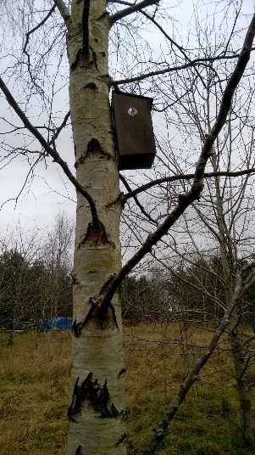 | The Drumoig Wildlife Forum was launched in January 2017, and the then DCT (now DRA) funded the purchase of twenty wooden bird boxes with the hope that a range of small woodland birds might nest in them. They were each numbered and located in the woodlands around the Drumoig golf course.  Since then, Paul and I have undertaken an annual survey of the bird boxes, to monitor the number of boxes having nests, to clean them and undertake any maintenance required. It was very encouraging to find that after just one year nine boxes had nests.  However, over the years a number of these boxes were found to have been damaged, some beyond repair.
In addition, in 2021 Alec Burden, Craigie Hill made three very substantial new wooden boxes to replace some of the original damaged ones and placed these in the woodland.

By the Spring of 2021 we had thirty-two woodland bird boxes, plus a Tawny Owl box, also made by Alec and a Barn Owl Box found damaged and repaired by Gordon and Tristan Bruce from Forgan Drive.
The 2021 nest box survey has just been undertaken and 20 (15 Schwegler, 2 original boxes and 3 made by Alec) had nests in them. Of the remaining 12 boxes, 3 were damaged beyond repair and 9 had no nests.
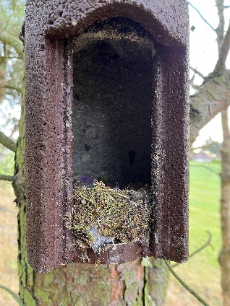 |  | 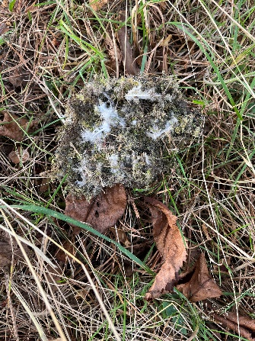 | 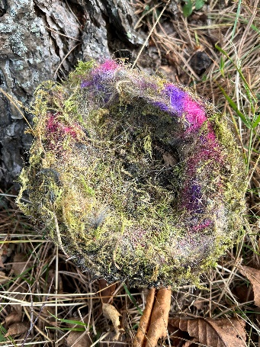
Schwegler box with nest |  | Nest filled with feathers | Winner of the most colourful nest

GARDEN BIRD BOXES.
If you have a bird box in your garden, this is the time of year to undertake maintenance, and below is guidance issued by the RSPB.

Old nests should be removed in the autumn from September onwards once the birds have stopped using the box. However, take care to ensure the nest is no longer active as some species can nest right through to September.

Unhatched eggs in the nest box can only legally be removed between September and January and must then be disposed of (it is quite normal for a few eggs to fail to hatch, or for some young to die in the nest. Blue and great tits for example can lay up to fourteen eggs to allow for such losses.

Once the nest has been removed from the box, boiling water should be used to kill any remaining parasites. The box should be left to dry out thoroughly before replacing the lid. Insecticides and flea powders must not be used in the box. Your box is then ready for next Spring and hopefully a new family of birds.

FEEDING GARDEN BIRDS.
RSPB Big Garden Birdwatch
Friday 28 to Sunday 30 January 2022

To sign up to take part in this annual or for more information please go to: Big Garden Birdwatch | The RSPB

A LADYBIRD & DRAGONFLY TO THE RESCUE.

You may remember that our garden bench was being eaten by wasps. A new peril has descended. Pigeons have taken a liking to sitting on the superstructure and pooping on the seats and table! We are obviously not meant to benefit from this piece of garden equipment but we have been tipped off as to a potential solution – ornamental windmills!

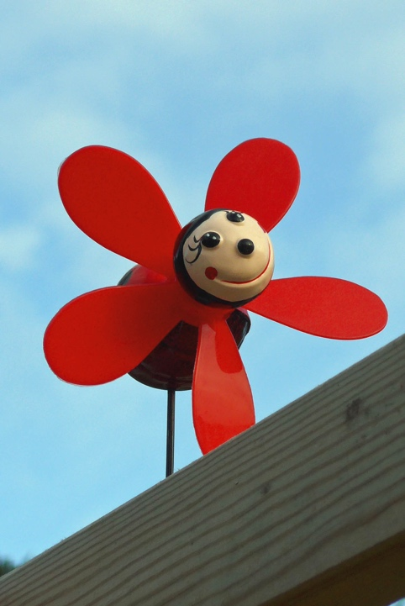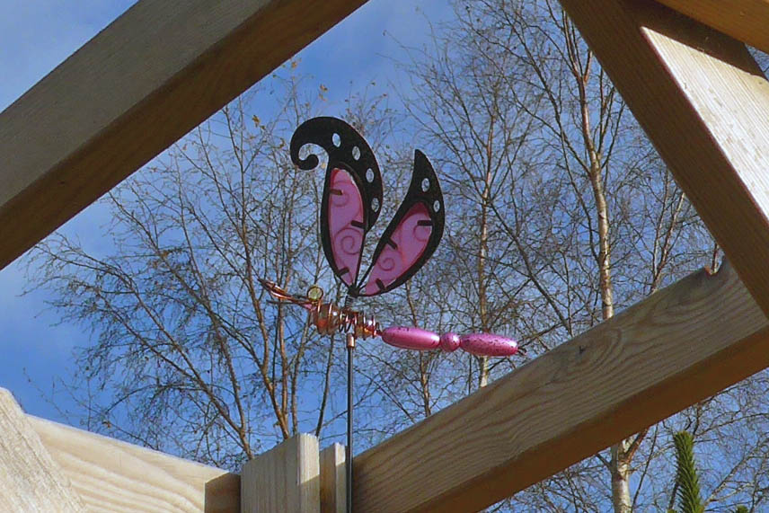

So here they are in place. If they survive the winter storms, I’ll let you know how they get on.

A STUDY OF THE FLY AGARICS/REDCAPS AROUND DRUMOIG.
I am indebted to Steve Norrie who, no doubt inspired by the article about Redcap toadstools in the last newsletter, went round the golf course and took the following photos of Redcaps in various stages of maturity.
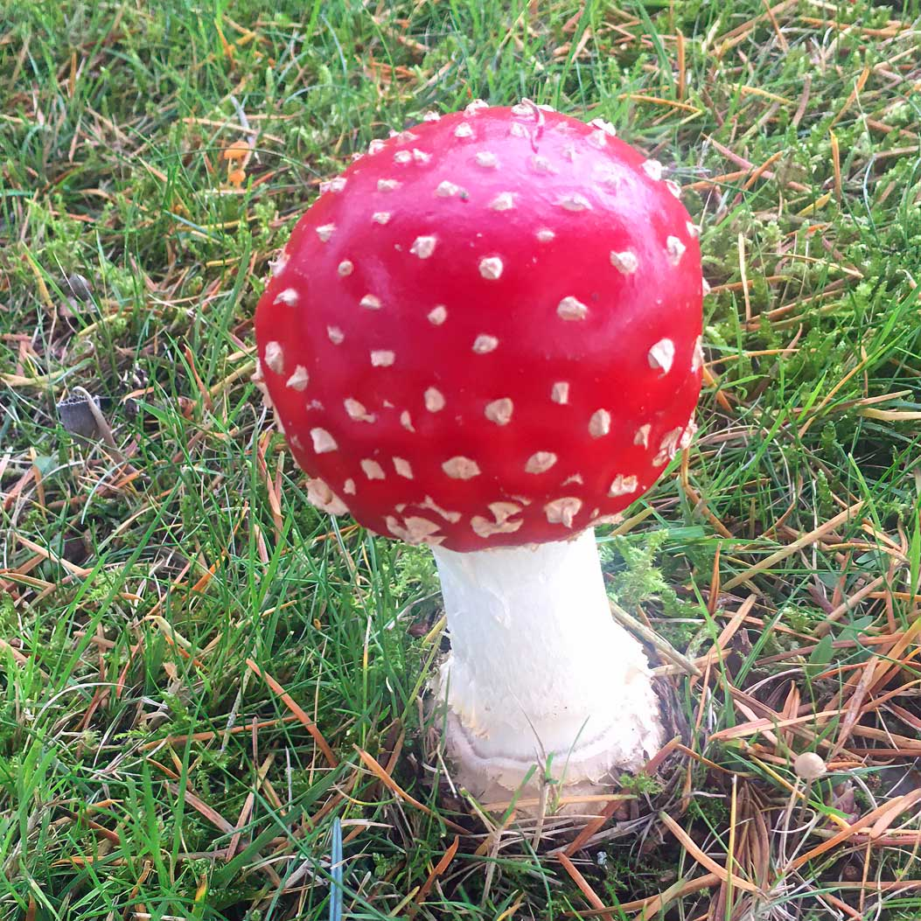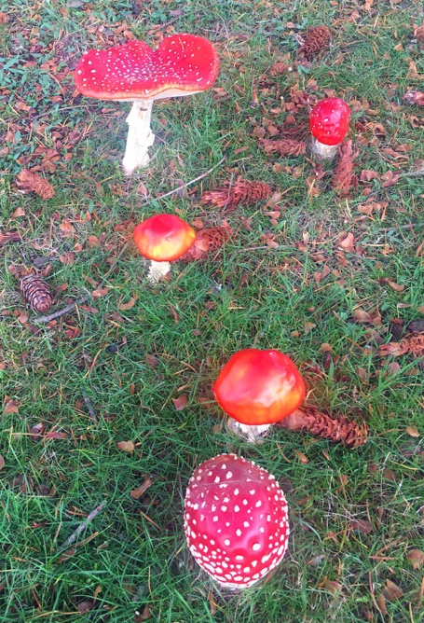

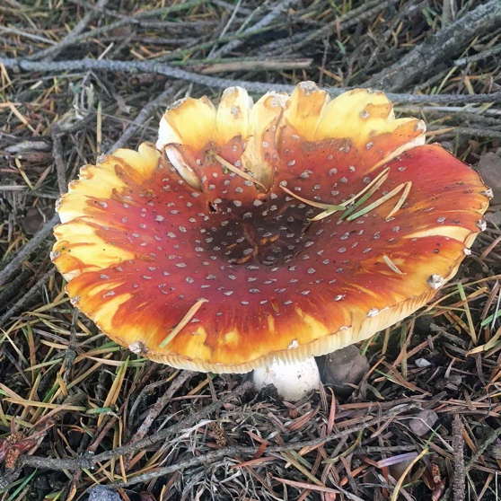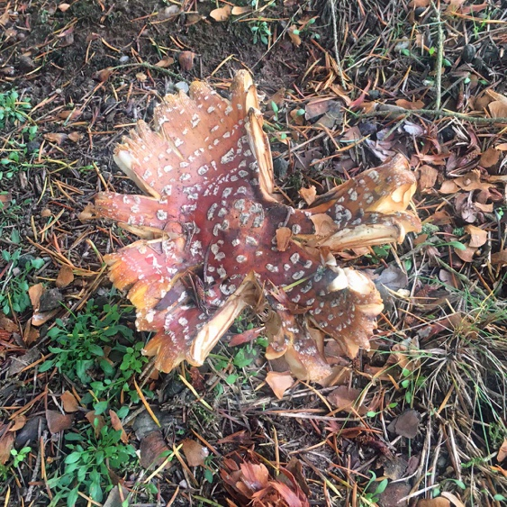

And finally, Steve managed to get a shot of the very rare golf ball variety, known as the Covid Special Edition:-
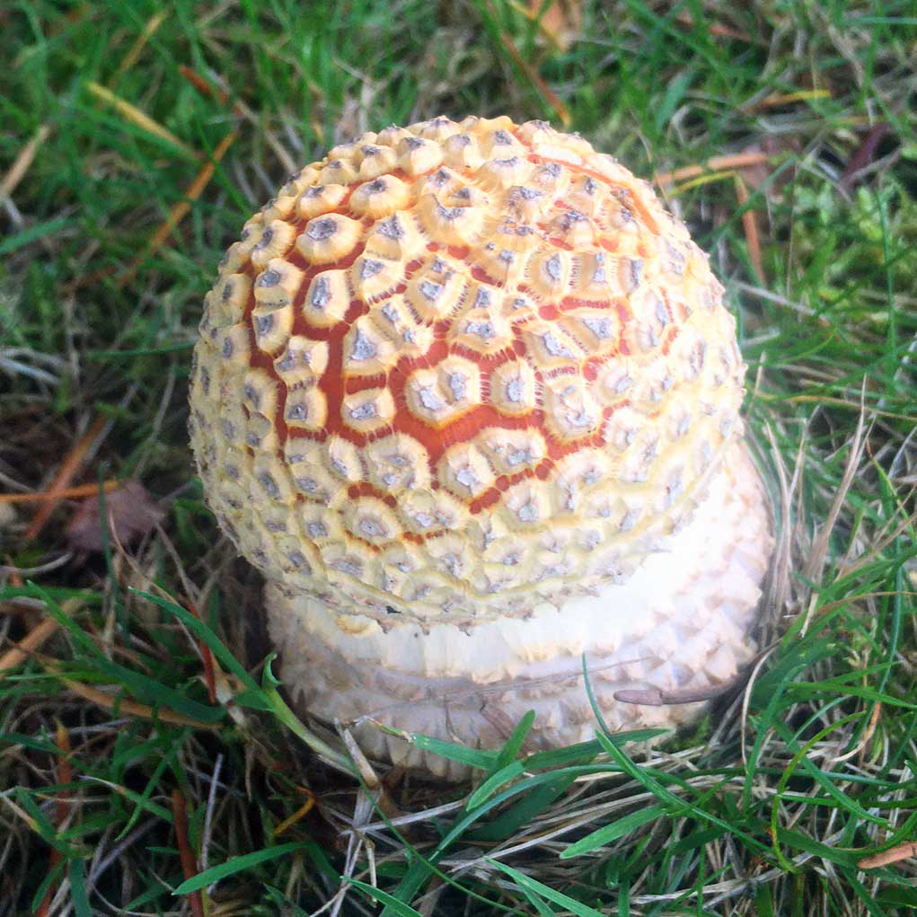
The rare Covid Edition golf ball
WINTER NIGHT SKY 2 – Steve Norrie
Winter now established sees Orion still dominating the night sky with Sirius - the dog star -brightly shining low and east of it. High overhead is the constellation of Auriga - the Charioteer - with its brightest star Capella showing a golden yellow hue if you avert your vision. Capella is the 6th brightest star in the sky with previously mentioned Sirius the brightest. Once the Moon disappears look out for the Milky Way high overhead and keep averting your vision to get your best view. Again, remember to dark adapt your eyes for some time – if you go outside from a bright room, you are unlikely to see much. With a good dark, sky you may even see our neighbour galaxy - Andromeda - as a small smudge just beside the Pegasus constellation.
Planets are limited to just a few with Jupiter sinking low in the early evening with Venus, although bright, again low on the horizon chasing the Sun.
Not quite so bright as stars are asteroids. Although asteroids orbit the Sun like planets, they are much smaller than them. They are irregular rocky objects that orbit the sun and most of them live in the main asteroid belt—a region between the orbits of Mars and Jupiter. Their size can vary between approximately 500 km to just a large rocky boulder and thankfully most of them pass by the Earth harmlessly if they do wander near to us! The chances are you will not see an asteroid with the naked eye but can spot them with optical aids and photograph them if you have a sensitive astro-camera and know where to look.

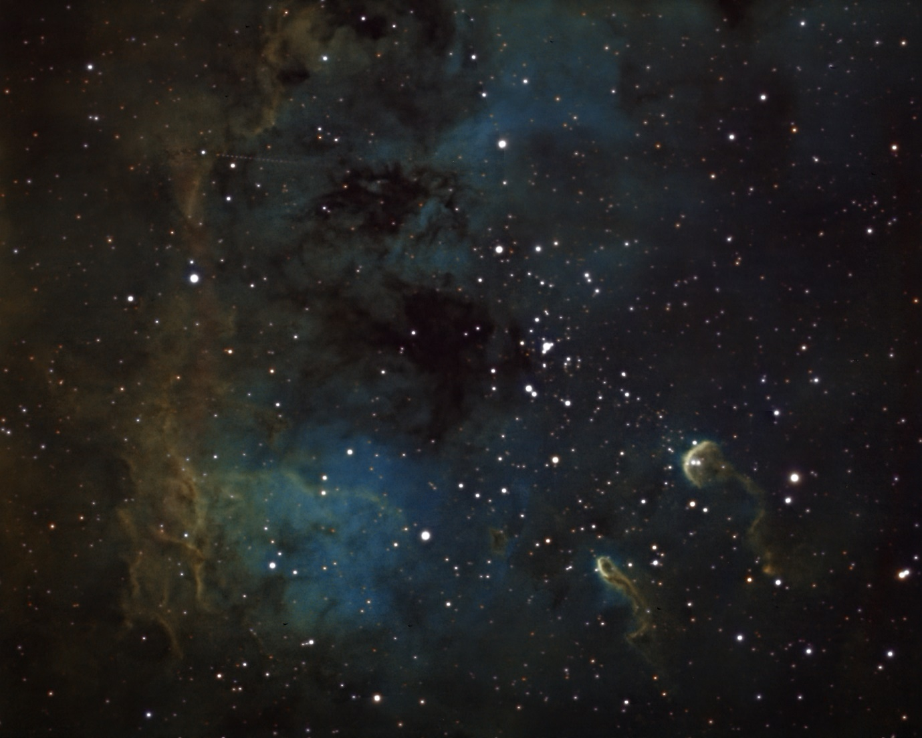

This is an image of the Tadpole nebula taken on 10th December showing the magnitude 13.9 asteroid named Caecilia. The image was taken over a period of 6 hours stacking multiple images and if you look closely at the top left you can see the series of dots showing the asteroid – an unintentional bonus for my picture! (An earth launched satellite crossing the image would appear as a white streak which the stacking software would eliminate through clever processing.)
You don’t want to see an asteroid looming large in the sky – just ask the dinosaurs!!

Hopefully by the time this is published the new James Webb Space Telescope will have successfully launched. This long-awaited project will surely give us some new even deeper sky images as its technology and capability far outweigh the current Hubble scope. It will seek out targets further back in time and provide a fascinating window into our universe’s darkest regions.
Interesting times for astronomy and science.

---------

As always, this newsletter will not happen unless you, the members, contribute. Please, please, please send me any observations, comments or photographs – there’s always something of interest happening around Drumoig!

Martin Hepworth

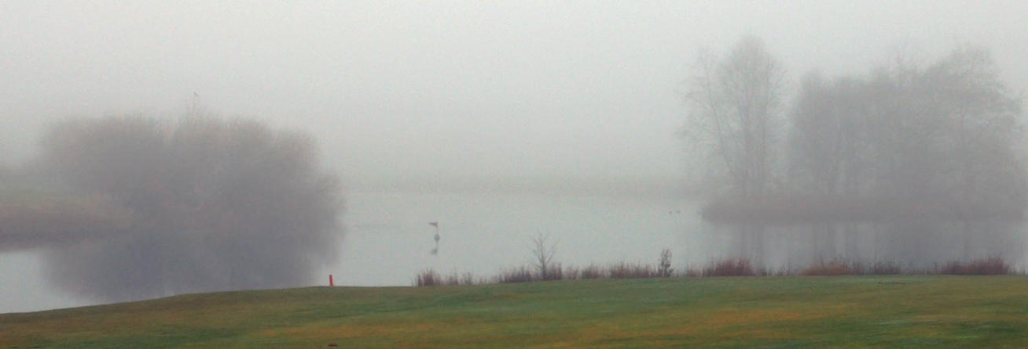

A HAPPY NEW YEAR TO ALL OUR READERS, WITH THE FERVENT HOPE THAT IT WILL BE MUCH BETTER THAN 2021.

