DRUMOIG WILDLIFE QUIZ (5) – 20 September 2018
No. | Question |  |  | Answer | Points
1. | What is the name of the shallow depression that hares use to give birth to their young?
2. | Name these members of the tit family (1 point for each)
 | 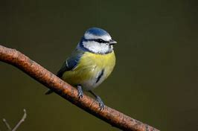 |  | 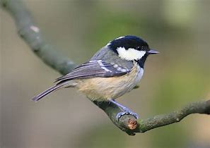
Answer | a) |  | b)
 | 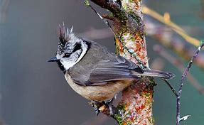 |  | 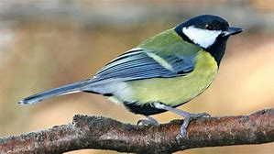
Answer | c) |  | d)
3. | What is a young deer called?
4. | The Butterfly Conservation celebrated a special anniversary this year. How many years was it?  a. 25  b. 50  c. 75
5.  Answer | Name these shrubs (1 point for each)
 | 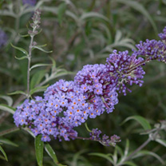 | 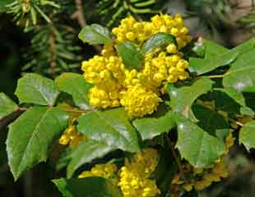 |  | 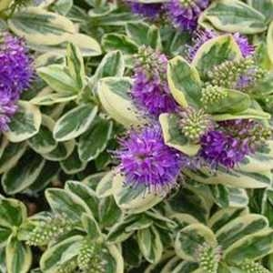
 | a) | b) |  | c)
6. | What is the collective name for a group of Owls?
7. | What is this insect called?  - Hornet  - Common Banded Hoverfly  - Wasp |  |  | 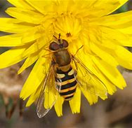
8. | What is a female hedgehog called?
9. | What bird can climb up a tree but can’t climb down it?
10. | How can you tell a stoat from a weasel?

In the event that more than one entry has the highest points then the entries will be put into a draw and the winner will then be chosen. If your entry is put in the draw please put your name below:

