DRUMOIG WILDLIFE QUIZ – 10 May 2018
No. | Question |  |  | Answer | Points
1. | What do you call an eagles nest
2. | Name these members of the thrush family (1 point for each)
 | 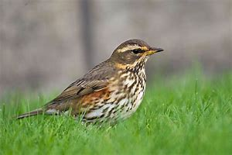 |  | 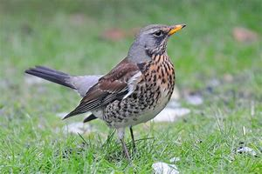
Answer | a) |  | b)
 | 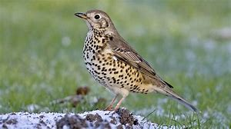 |  | 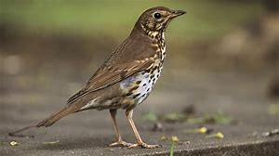
Answer | c) |  | d)
3. | What is a male European badger called?
4. | In which year was the RSPB (Royal Society for the Protection of Birds) founded?  a. 1766  b. 1889  c. 1905
5.  Answer | Name these wildflowers (1 point for each)
 | 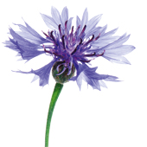 | 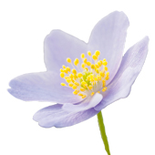 |  | 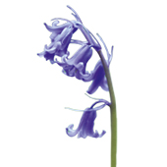
 | a) | b) |  | c)
6. | What is the collective name for goldfinches?
7. | What is this moth called?  - Garden Cheetah Moth  - Garden Zebra Moth  - Garden Tiger Moth |  |  | 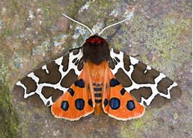
8. | What is a female deer called?
9. | Which shy woodland bird, a colourful member of the crow family has the scientific name Garrulus glandarius?
10. | How many fingers and toes do Red Squirrels have? (1 point for (a) and 1 point for (b))  a) Fingers b) Toes

In the event that more than one entry has the highest points then the entries will be put into a draw and the winner will then be chosen. If your entry is put in the draw please put your name below:

