DRUMOIG WILDLIFE QUIZ – 26 September 2017
No. | Question |  | Answer | Points
1. | What do you call the nest of a Red Squirrel?
2. | Name these ducks (these are the male of the species) – 1 point for each
 | 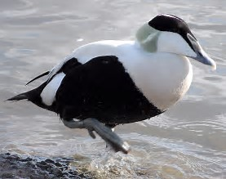 | 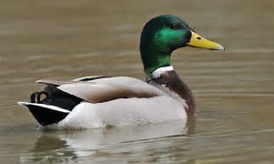 | 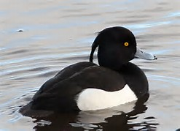
3. | What is a female fox called?
4. | What do you call a group of Buzzards?
5.  Answer | Name these wildflowers (1 point for each)
 | 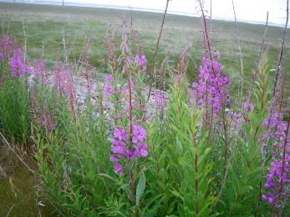 | 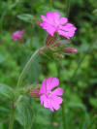 | 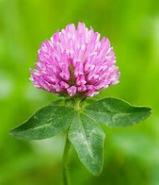
 | a) | b) | c)
6. | A leveret is the young of which animal?
7. | What moth is this? | 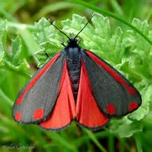
8. | Every year, migratory Whooper and Bewick swans fly to the Cambridgeshire and Norfolk Fens from their Summer homes. Approximately how far do they travel to get there?  - 1,750 miles  - 2,250 miles  - 2500 miles
9. | Which black and white bird of the crow family has the scientific name Pica pica?
10. | 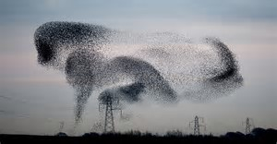 | What is this bird phenomenon known as?

In the event that more than one entry has the highest points then the entries will be put into a draw and the winner will then be chosen. If your entry is put in the draw please put your name below:

