DRUMOIG WILDLIFE QUIZ – 11 April 2017
No. | Question |  |  |  |  | Answer | Points
1 | What do you call the home of a badger?
2.  Answer | Name these Amphibians (1 point for each)
 | 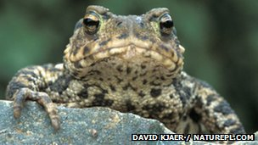 |  |  | 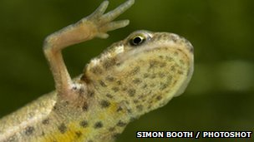 |  | 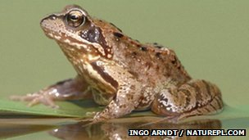
 | a) |  |  | b) |  | c)
3. | - Where on a butterfly would you find it's taste sensors?
4. | Which British bird lays the largest egg?
5.  Answer | Name these wildflowers (1 point for each)
 | 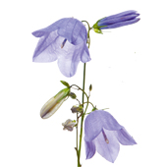 |  | 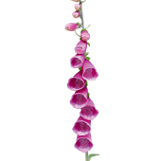 |  |  | 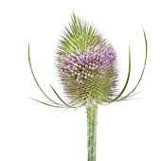
 | a) |  | b) |  |  | c)
6. | What are young squirrels called?
7. | What bird is this? |  |  |  | 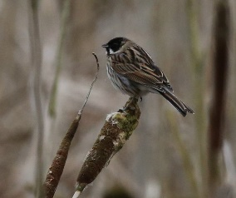
8. | How many insects can a tiny pipistrelle bat eat in a night  - 1000  - 2000  - 3000
9. | How old is an oak tree when it starts producing acorns?  - 5 years old  - 20 years old  - 40 years old
10. | 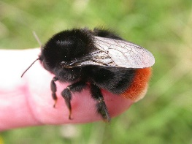 | What is the name of this Bumblebee?  - The Fluffy-bottomed  - The Big-bottomed  - The Red-bottomed  - The Red-tailed

In the event that more than one entry has the highest points then the entries will be put into a draw and the winner will then be chosen. If your entry is put in the draw please put your name below:

