DRUMOIG WILDLIFE QUIZ - 28 February 2017

No. | Question |  |  |  | Answer | Points
1 | What type of animal would live in a HOLT?
2.  Answer | Name these butterflies (1 point for each)
 | 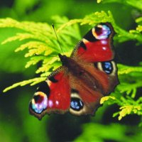 |  |  | 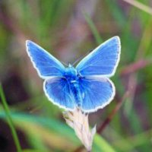 | 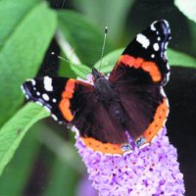
 | a) |  |  | b) | c)
3. | Which is the only mammal in the UK that is able to fly?
4. | How many eyes does a honey bee have?  - 2  - 4  - 5  - 6
5. | What bird features on the logo of the RSPB?
6.  Answer | Name the trees these leaves come from (1 point for each)
 | 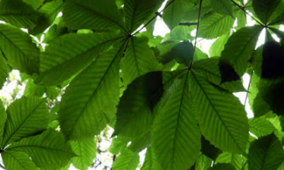 |  | 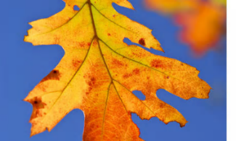 |  | 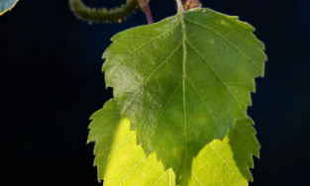
 | a) |  | b) |  | c)
7. | What are the young of pigeons known as?
8. | Which bird appeared on the old British farthing coin?
9. | What is another name for the Mountain Ash?
10. | 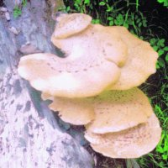 | Is this Fungi a  - Giant Puffball  - Velvet Shank  - Bracket Fungi
Total

In the event that more than one entry has the highest points then the entries will be put into a draw and the winner will then be chosen. If your entry is put in the draw please put your name below:

